
4Software Engineering Department
Braude College of Engineering
Final Project – Phase A (61998)

Title
Automated Voice-Guided Software Specification and Generation

subtitle
CODE: 26-2-D-15

By:
Yair Zeneve
Shay Liberman

Advisor:
Dr. Natali Levi

Link to GitHub:
https://github.com/YairZen/FinalProject

Abstract
Requirements engineering and software architecture remain significant barriers for non-technical entrepreneurs, often preventing abstract business ideas from becoming operational products. Existing generative AI tools, while offering basic code generation, frequently fail to develop complex software due to hallucinations, lack of architectural planning, and the inability to verify code functionality. This project introduces an innovative, voice-guided software specification and generation platform designed to bridge that gap through a structured multi-agent framework. The system allows users to articulate their requirements vocally in a guided, goal-oriented dialogue, translating natural speech directly into a formal system model. Using advanced natural language processing (NLP), large language models (LLMs), stateful orchestration, and isolated runtime sandboxing, the platform autonomously designs, codes, tests, and self-repairs the software. The goal is to eliminate technical barriers, ensuring architectural integrity and functional stability without human intervention. The system is designed for non-technical founders and development teams, offering a scalable, end-to-end solution for automated software creation.

Contents
1. Introduction 6
2. Related Work 8
2.1 Foundational Requirements Elicitation and Conversational Interfaces 8
2.2 Limitations of Existing Automated Generation Paradigms 9
2.3 Architectures of Autonomous Multi-Agent Frameworks 10
2.4 Closed-Loop Verification and Autonomous Self-Correction 11
3. Requirements 13
3.1 Functional Requirements (FR) 13
3.2 Non-Functional Requirements (NFR) 15
4. Research and Development Methodology 17
4.1 Multi-Agent Network Architecture 17
4.1.1 Central Orchestrator 17
4.1.2 Product Manager (PM) Agent 18
4.1.3 Architect Agent 19
4.1.4 Software Developer Agent 20
4.1.5 QA & Debugging Agent 20
4.1.6 Deployment Component 21
4.2 Technology Stack 22
4.2.1 Agent Management & Orchestration 22
4.2.2 Large Language Models (LLM) – Approach 22
4.2.3 Sandboxing & Secure Execution 23
4.2.4 Code Quality & Static Analysis 23
4.3 Anticipated Challenges 23
5. User interface 24
Figure 1: Project Dashboard and Session Management. 24
Figure 2: Voice-Guided Interview and Simplified Artifact Review 24
Figure 3: Final Generation Delivery 25
6. Diagrams 26
6.1 Package and Deployment
6.2 Use case 26
6.3: Activity 27
7. Project KPIs & Success Metrics 28
7.1 Requirements Elicitation (PM Agent) 28
7.2 Architectural Design (Architect Agent) 28
7.3 Code Quality & Correctness (Developer + QA Agents) 28
7.4 End-to-End System 29
8. Testing Plan 30
8.1 Unit Testing - Deterministic Modules 30
8.2 Integration Testing - Inter-Agent Data Contracts 30
8.3 Sandbox QA Testing - Generated Code Verification 30
8.4 End-to-End Pipeline Testing 30
8.5 User Acceptance Testing (UAT) 31
9. References 32

1. Introduction
Requirements engineering is a core phase of the software development lifecycle (SDLC), responsible for translating abstract business intent into formal technical specifications [1]. For non-technical entrepreneurs, this phase is a major barrier as they rarely have the training to write formal requirements or design data schemas [2]. Bridging this gap has traditionally relied on product managers and systems analysts conducting extensive stakeholder interviews, a process that is slow, expensive, and prone to miscommunication [2].
While current LLMs can generate code from natural language, general-purpose models cannot solve the requirements gap on their own [4]. Without a structured framework, they tend to hallucinate, lose context, and fail on complex tasks [4]. Recent studies show that single-agent models work well with clear instructions, but multi-agent systems perform better when handling messy, unstructured input [10]. This makes a multi-agent approach ideal for non-technical users describing their needs out loud.
This project addresses these challenges by proposing an automated platform that integrates requirements engineering and software generation within a structured, hierarchical multi-agent framework built around a central Orchestrator and a set of purpose-built sub-agents.
Instead of using a single model for every phase, the framework enforces role separation and sequential task execution under strict orchestrator control [3][5][7][8]. A voice-guided dialogue helps the user define their needs and build a structured requirements model. Based on Goal-Oriented Requirements Engineering (GORE) [2] and IEEE Std 29148-2018 principles [1], this ensures the captured requirements are complete, consistent, unambiguous, and verifiable [1]. The platform automatically converts these models into standard artifacts like Software Requirements Specifications (SRS), user stories, and data schemas [1]. Sub-agents then translate these specifications into source code, testing it within an isolated sandbox to deliver a stable working application [6][9].
Ultimately, the platform benefits two main groups. For non-technical entrepreneurs, it removes technical and financial barriers, letting them turn abstract business goals into working software through natural dialogue alone [2]. For technical teams, it provides an automated pipeline that generates traceable, standard-conforming artifacts from the first interaction, directly addressing the hallucination and reproducibility problems shown in current generative AI research [4].

2. Related Work

2.1 Foundational Requirements Elicitation and Conversational Interfaces
Requirements elicitation is a knowledge-intensive activity bounded by the semantic ambiguities of natural language [4]. IEEE 29148 defines elicitation as a structured process to capture stakeholder needs, establishing that a conforming SRS must be complete, consistent, unambiguous, and verifiable; these are properties rarely achieved through informal dialogue [1]. A systematic review of generative AI in requirements engineering found that while 52.1% of current research addresses elicitation, fewer than 1.3% of implementations achieve verified, production-ready integration. The main barriers are hallucinations (63.4%), reproducibility deficits (66.8%), and interpretability limitations (57.1%) [4].
Goal-Oriented Requirements Engineering (GORE), as formalised by van Lamsweerde, provides a principled foundation for addressing this gap [2]. GORE establishes that formal specifications should be derived by progressively refining high-level stakeholder goals, rather than directly eliciting implementation details from users who may lack the vocabulary to express them precisely [2]. This refinement process maps directly onto the structured dialogue conducted by the project's Interviewer sub-agent. To ensure verifiable and unambiguous inputs, the system employs an active conversational approach to resolve natural language ambiguities [1]. Furthermore, the project draws on Model-Based Systems Engineering (MBSE), which dictates that all engineering artifacts should originate from a single shared model to prevent documentation drift [11]. This principle drives the Authoritative Source of Truth (ASoT) used in this system which is a central model that all agents read from and write to, ensuring complete synchronization across all phases.

2.2 Limitations of Existing Automated Generation Paradigms
Single-agent tools, no-code platforms, and model-driven design tools all have limits for non-technical users. Single-agent models work well with clear input, but get worse when the input is messy, which matches how non-technical users describe what they need [10]. Hallucination and unreliable output are still common problems with these tools [4]. No-code platforms let users build software, but give no clear link between what the user asked for and what got built, the user still has to design the architecture alone. Model-driven tools fix this by using one shared model for everything, but they need UML skills that most non-technical users don't have [11].

2.3 Architectures of Autonomous Multi-Agent Frameworks
The transition from monolithic LLM completion to agentic, goal-driven systems is well-established in automated software development [7]. ChatDev demonstrates that the SDLC can be decomposed into specialised agent roles, Product Manager, Architect, Programmer, Tester, communicating over structured channels [7]. MetaGPT advances this by embedding Standard Operating Procedures (SOPs) into the agent reasoning loop and requiring formal intermediate artifacts before code is produced, empirically reducing hallucinations and maintaining architectural consistency compared to free-form generation [8].
Open, unconstrained agent topologies introduce a critical vulnerability: uncontrolled debate generates token bloat and high problem-drift rates, where agents progressively lose track of core requirements [4][5]. MAS-Orchestra demonstrates that centralised orchestration, a single control layer managing agent invocation sequencing, context routing, and task decomposition, measurably improves reasoning quality and reduces inter-agent inconsistency [5]. This finding directly motivates the strict Orchestrator + Sub-agents hierarchy in this project, in which the Orchestrator is the sole coordination point, invoking sub-agents in a controlled sequence and maintaining the shared ASoT across all invocations.
Knowledge-driven frameworks have advanced multi-agent RE further still. The iReDev framework orchestrates knowledge-injected roles (Interviewer, End-User, Deployer, Analyst, Archivist, Reviewer) interacting through a centralised artefact pool, producing traceable requirements artefacts without free-form debate [3]. QUARE takes a different approach: it uses five separate agents, each focused on one quality goal (like safety or efficiency), that directly debate each other to resolve conflicts between requirements [12]. This project does not let agents talk to each other directly, instead, agents write requests to the shared ASoT, and the Orchestrator decides which agent responds next. This keeps the system simpler and more predictable, even though it gives up the deeper back-and-forth that QUARE's direct agent debate allows. Collectively, these frameworks establish that orchestrator-controlled, knowledge-guided multi-agent collaboration is the principled architecture for reliable AI-assisted requirements engineering.

2.4 Closed-Loop Verification and Autonomous Self-Correction
Because standalone models lack a native compiler-execution layer, they cannot autonomously verify functional stability. The established solution is a closed-loop architecture linking the LLM to a runtime environment, enabling compiler-informed self-correction [6].
The Self-Debugging framework demonstrates that LLMs can use compiler error messages and test failure outputs as structured feedback to execute autonomous repair cycles, correcting their own code without requiring human relay of error information [6]. CRITIC framework extends this by showing that equipping agents with external tools, compilers, linters, test runners, enables systematic self-correction of factual, logical, and code-level errors that chain-of-thought reasoning alone cannot reliably detect [9]. Together, these studies provide the empirical basis for this project's Debugging sub-agent, which receives structured execution logs from the Orchestrator and applies tool-augmented refinement cycles until the generated system satisfies all verification criteria [6][9].

3. Requirements

3.1 Functional Requirements (FR)
Note: This section highlights the core functional requirements of the system. The complete and detailed list, including all sub-requirements, is available in Appendices.
ID | Category | Streamlined Engineering Description
FR-1 | Voice Input | The system shall capture user speech via a microphone interface and transcribe it using a Speech-to-Text (STT) engine.
FR-2 | Clarification Dialogue | The Interviewer sub-agent shall run a goal-oriented requirements dialogue, generating targeted clarification questions to establish system boundaries.
FR-2.3 | ASoT Population | The system shall automatically record and organize every requirement captured from the user into a central database (Authoritative Source of Truth, ASoT) in real time.
FR-3 | Human-in-the-Loop | The system shall render a visual summary of the requirements model for explicit user review and approval prior to artifact generation.
FR-4 | Documentation | Upon model approval, the system shall automatically generate an IEEE 29148-conforming Software Requirements Specification (SRS).
FR-5 | Code Generation | The system shall generate a functional full-stack software (database, backend API, and frontend UI) directly from the ASoT.
FR-6 | Sandboxed QA | The Orchestrator shall call a sub-agent to isolate, compile, and execute the generated source code within a sandboxed runtime environment for automated analysis.
FR-6.4 | Self-Correction | The Debugging sub-agent shall analyze the compiled diagnostic packets and execute iterative self-correction cycles until all metrics pass or the retry cap is met.
FR-7 | Orchestration | The central Orchestrator shall strictly enforce the sequential invocation of sub-agents, passing only the Session ID.

3.2 Non-Functional Requirements (NFR)
Note: This section highlights the core non-functional requirements of the system. The complete and detailed list, including all sub-requirements, is available in Appendices.
ID | Category | Streamlined Engineering Description
NFR-1 | Usability – Requirements Guidance | The dialogue phase shall programmatically enforce GORE and IEEE Std 29148-2018 validation criteria, remaining active until all requirements are verified as complete, consistent, unambiguous, and verifiable.
NFR-4 | Maintainability – Artifact Traceability | Every approved requirement must link directly to a specific part of the final code and documentation.
NFR-5 | Compatibility – Runtime Environment | The output code bundle must build and deploy successfully inside standard Docker containers without requiring manual human code modifications.
NFR-7 | Reliability – Verification Coverage | Generated test blocks must achieve 100% execution coverage across all generated REST API endpoints and database CRUD functions.
NFR-9 | Compatibility – Standards & APIs | The SRS document must conform to IEEE Std 29148-2018 requirements, and all generated API endpoints must match the OpenAPI 3.x specification.
NFR-10 | Reliability – Orchestrator State | The Orchestrator shall isolate sub-agent runtime failures, log exception signatures, and execute retries without corrupting active ASoT memory state.
NFR-12 | Scalability – Concurrent Sessions | The system backend must support concurrent isolated multi-user sessions without introducing latency degradation or database leakage.
NFR-13 | Reliability – Self-Correction Limit | The closed-loop debugging mechanism shall terminate and output a structured diagnostic failure report after N unsuccessful code-repair iterations.

4. Research and Development Methodology
This project uses an Iterative and Incremental Development (IID) methodology to automate the Software Development Life Cycle (SDLC). The system transforms unstructured voice input into a fully validated, functional software product, reducing the need for technical expertise during requirements gathering and design.

4.1 Multi-Agent Network Architecture
The core backend architecture is based on an orchestrated multi-agent system composed of specialized autonomous sub-agents governed by a deterministic Central Orchestrator. To ensure architectural integrity, the agents do not communicate directly with one another. Instead, they are strictly coordinated by the Central Orchestrator, which routes execution dynamically based on each agent's output. Each sub-agent is designed to be stateless, pulling and pushing data exclusively from a centralized database that serves as the Authoritative Source of Truth (ASoT). Data contracts and structural validation between agent boundaries are strictly enforced using Pydantic library schemas.

4.1.1 Central Orchestrator
Role: Manages the execution order of all sub-agents, decides where to route execution after each step, enforces retry limits, and ensures sub-agent failures do not corrupt or roll back previously confirmed state.
Implementation: Built as a LangGraph StateGraph - a directed graph where each node is a sub-agent invocation and each edge is a routing function that reads the current session state and decides what runs next. It’s purely rule-based routing with no LLM calls. The session state is a shared typed object containing the current phase, a retry counter per sub-agent, and the last reported signal from each agent. LangGraph automatically saves this state to the database after every step, meaning a crash or failure at any point leaves all prior confirmed work intact.
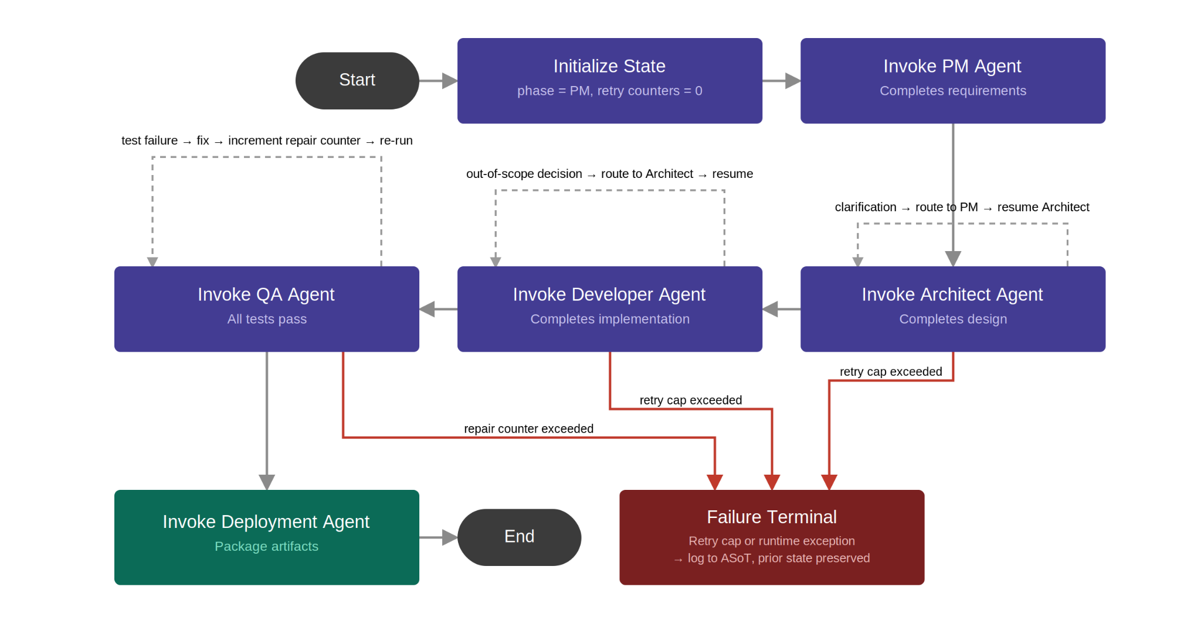
Algorithmic Flow:

4.1.2 Product Manager (PM) Agent
Role: Transforms unstructured voice input into a formally validated requirements model satisfying IEEE 29148-2018 completeness criteria, through a guided, adaptive dialogue with the user.
Implementation: Operates on a conversational LLM whose system prompt injects IEEE 29148-2018 quality constraints. The LLM is strictly limited to content generation, extracting requirements and phrasing questions. All control-flow decisions are made deterministically by the surrounding code. The agent additionally infers the user's technical literacy level from linguistic signals each turn, adapting question complexity accordingly.
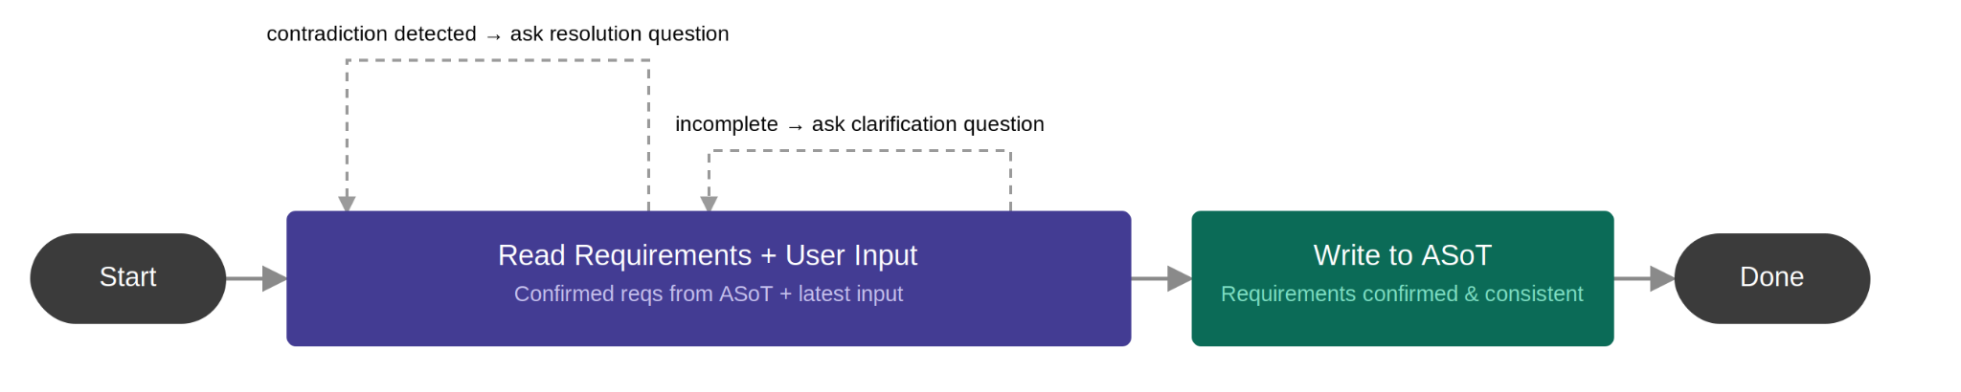
Algorithmic Flow (Reason + Act Loop):

4.1.3 Architect Agent
Role: Translates the validated requirements model into a complete design document: relational schema, API contract, component architecture, and technology decisions - from which the Developer agent can proceed without making independent structural decisions.
Implementation: Operates on OpenAI GPT-4o. The LLM is strictly limited to content generation: decomposing requirements into components, extracting entity-relationship structures, drafting technology decisions, and writing Architecture Decision Records (ADRs) documenting each decision, its rationale, rejected alternatives, and the requirement it satisfies. All structural verification is executed by four purpose-built deterministic modules: a Pydantic structure validator that rejects malformed LLM output before any other step runs, a 3NF normalization checker that identifies dependency violations in the entity model, an API coverage checker that runs a set difference between requirement IDs in the ASoT and endpoint mappings in the generated contract, and a constraint satisfaction filter that eliminates technology candidates violating hard constraints from the user's non-functional requirements. If any module reports a failure, the LLM is re-invoked with only the flagged items rather than regenerating the full design.
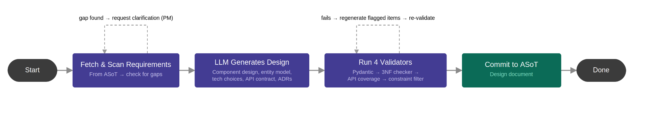
Algorithmic Flow (Constrained Design Loop):

4.1.4 Software Developer Agent
Role: Translates architectural specifications into executable source code, including database scripts, backend API endpoints, and UI components, while ensuring strict security standards and full engineering traceability.

Implementation: Operates on the Anthropic Claude 3.5 Sonnet model. The LLM is strictly limited to content generation: synthesizing code based on the Architect's API contracts and schemas. Rather than acting as a passive wrapper, the agent autonomously executes two explicit deterministic tools: a Security-Enforcement Tool (for injecting structured error handling and SQL injection protections), and a Traceability-Mapper Tool (for embedding structured metadata tags linking code blocks to ASoT requirements IDs) and a MyPy Static Type Checker (for verifying Python syntax and type consistency without execution). If an architectural gap is encountered, the agent makes an autonomous decision to halt rather than hallucinate. Crucially, if the deterministic tools fail to inject or map data due to malformed code generation, the agent uses the tool's feedback to autonomously resolve the specific block before proceeding.

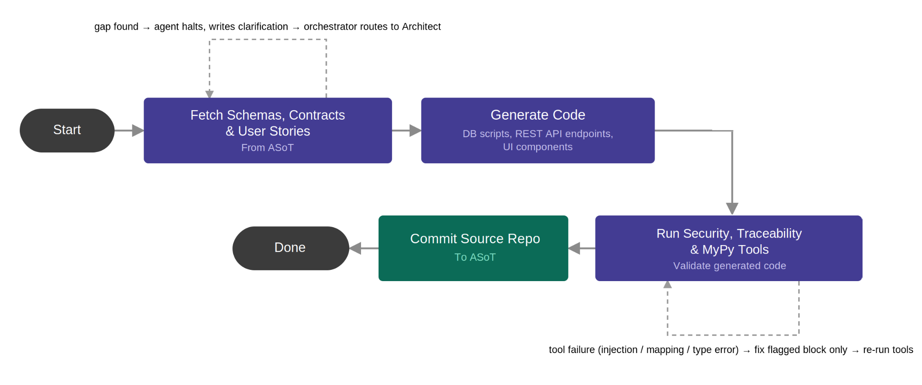
Algorithmic Flow (Pause and Wake + Tool Validation):

4.1.5 QA & Debugging Agent
Role: Automatically validates the generated source code by drafting and executing test suites inside an isolated sandbox, performing closed-loop self-repairs until the software is functionally stable and meets strict code health metrics.

Implementation: Operates on the Anthropic Claude 3.5 Sonnet model. The LLM handles all content generation: drafting unit and integration tests, analyzing failure root causes from stack traces, and writing the actual code fixes. All structural verification (compiling code, executing tests in a Docker sandbox, and measuring Cyclomatic Complexity using static analysis tools like Pylint and Radon) is executed by deterministic code. If a test fails, the agent enters an autonomous self-correction loop to actively fix and patch the codebase, If the retry cap is reached, the agent halts rather than infinitely looping.

Algorithmic Flow (Self-Correction Loop):
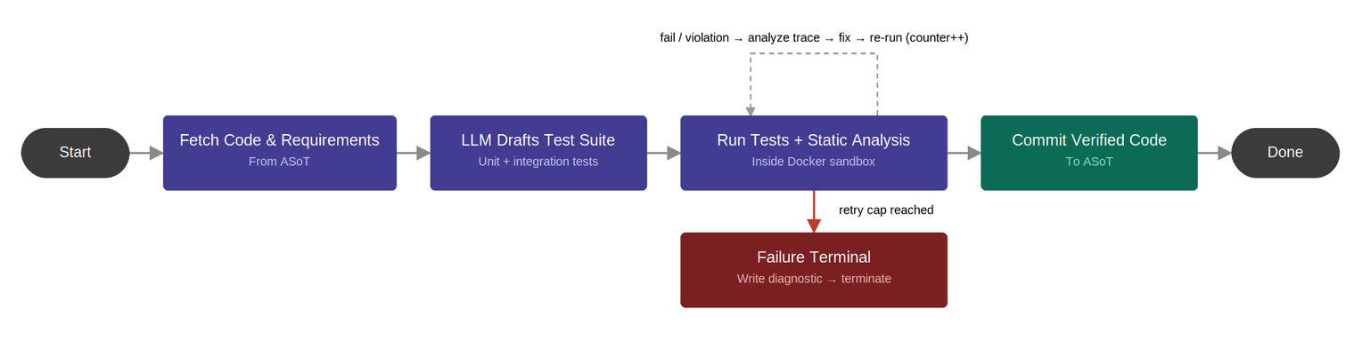

4.1.6 Deployment Component
Role: Packages the final source code and documents into standard Docker configurations so the application can easily run on any system.
Implementation: This is a standard software component, not an AI agent. It simply uses deterministic code to automatically create Docker files (Dockerfiles and Docker Compose), then it packages the source code, the Docker configurations, and the System Requirements Specification (SRS) document into a single, downloadable ZIP file.
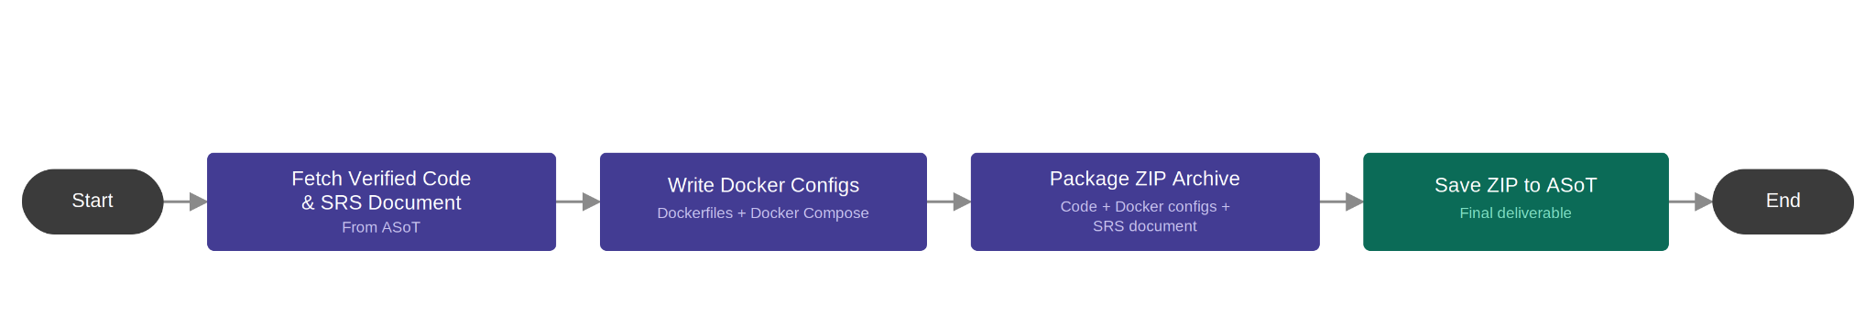
Algorithmic Flow (Packaging Pipeline):

4.2 Technology Stack
To successfully build and operate the system, we utilize an advanced development stack. This technical infrastructure is divided into the following four operational domains:

4.2.1 Agent Management & Orchestration
LangGraph and LangChain (Agent Development Kit - ADK): The core framework utilized to construct the agent network. Its native support for stateful cyclic graphs is critical for executing the iterative development, testing, and self-repair loops driven by the AI.
Pydantic: Integrated across all data mutation boundaries and agent communication paths to enforce strict data contracts, compile-time object validation, and global state integrity.
LangSmith (Agent Observability): A background visual tool for developers. It shows exactly which agent is currently active, displays its specific prompts and responses to help debug hallucinations, and tracks API token costs, all without affecting the system's main flow.

4.2.2 Large Language Models (LLM) – Approach
The system implements a hybrid architecture, assigning a specific model to each agent based on its role:
- Product Manager (PM) Agent: Powered by the local model Llama 3 8B (via Ollama). It runs locally to manage the continuous chat with the user. This ensures complete data privacy, fast response times, and zero API costs
- Architect Agent: Powered by OpenAI GPT-4o. Chosen for its strong logical reasoning skills, which are required for system planning, analyzing alternatives, and creating database schemas
- Software Developer Agent: Powered by Anthropic Claude 3.5 Sonnet. Selected for its industry-leading zero-shot coding abilities to generate all the system's source code
- QA & Debugging Agent: Powered by Anthropic Claude 3.5 Sonnet. Required for its massive context window, allowing it to read long error logs and perform automated code self-repair loops

4.2.3 Sandboxing & Secure Execution
Docker: Provides a completely isolated, lightweight containerized sandbox environment. All generated source code, unit test suites, and database migrations are compiled and executed inside containers, protecting the host machine from unverified execution code.
Python Subprocess Module: Utilized internally by the platform to securely launch system-level commands, trigger build chains, and capture raw standard streams (stdout and stderr).

4.2.4 Code Quality & Static Analysis
Pylint: Automatically checks the generated code for errors, bad practices, and ensures it follows standard formatting rules.
Radon: Measures code complexity to ensure the software remains clean and easy to maintain.

4.3 Anticipated Challenges
During the system's operation, three main technical challenges are anticipated:
- Context Drift and Hallucinations: As the interactive dialogue with the user expands, the LLM's context window can become overloaded with redundant data, leading to AI hallucinations and a loss of focus on the core software requirements.
- Infinite Self-Correction Loops: During the autonomous debugging phase, fixing a specific bug may unintentionally introduce a new regression. This creates a risk of an endless error-correction loop that consumes system resources without converging on a stable build.
- Non-Deterministic Code Generation: Large Language Models are inherently non deterministic. Generating code from the same prompt can yield variations in variable names or class structures, which may cause integration failures and mismatches between the API and database layers.
- Understanding User Story: Adequately breaking down user’s requirements, expectations and providing proper solution that will satisfy the user.

5. User interface

Figure 1: Project Dashboard and Session Management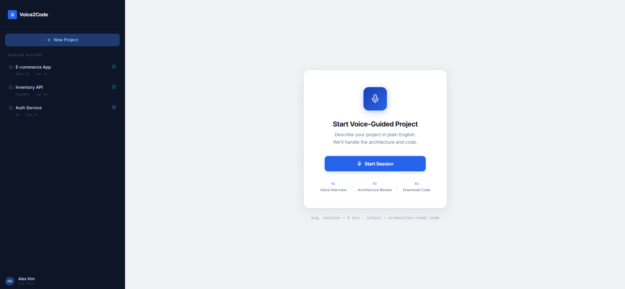 The dashboard shows past sessions and lets the user start a new project (NFR-12). . From this screen, the user can initiate a new software generation pipeline.

Figure 2: Voice-Guided Interview and Simplified Artifact Review
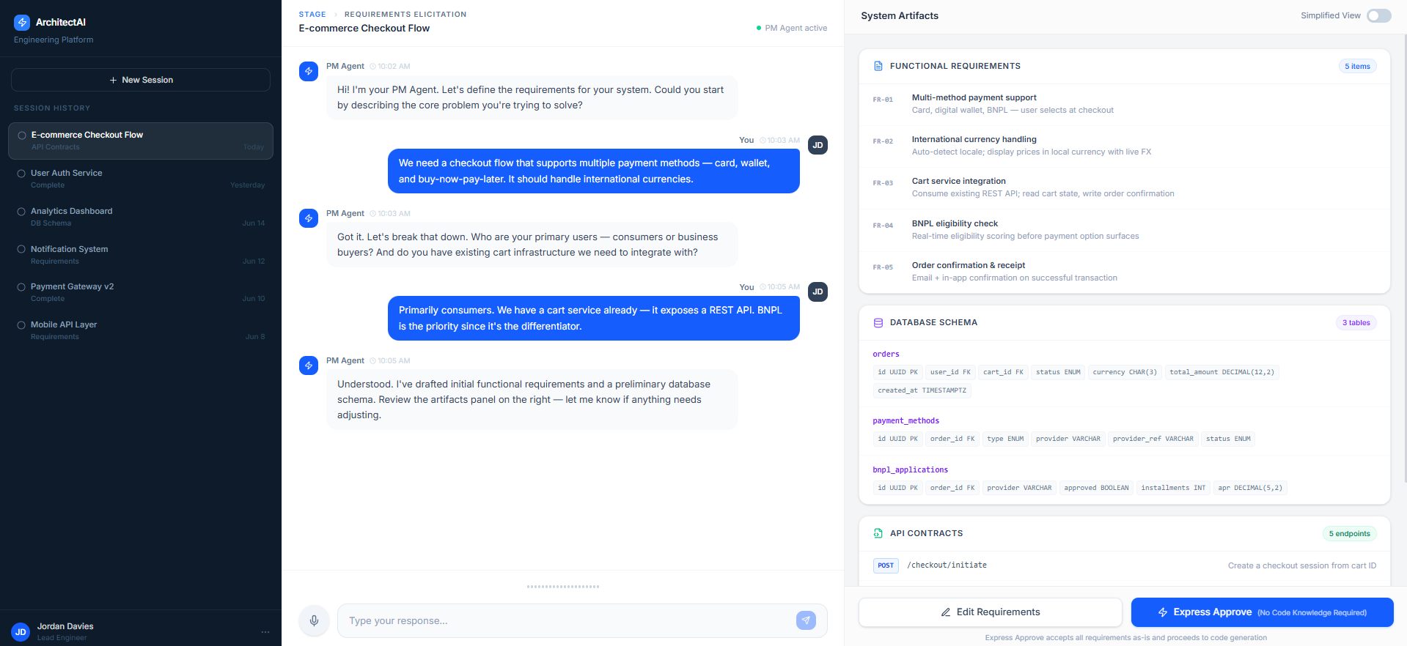
The core workspace is divided into an active voice dialogue panel (satisfying FR-1 and FR-2) and a real-time artifact viewer. To accommodate the target audience of non-technical entrepreneurs, the review panel features a 'Simplified View' toggle and an 'Express Approve' button alongside the raw technical documents. The user must explicitly approve the generated architecture using this panel, fulfilling the Human-in-the-Loop (HITL) requirement (FR-3) before any code is synthesized.

Figure 3: Final Generation Delivery
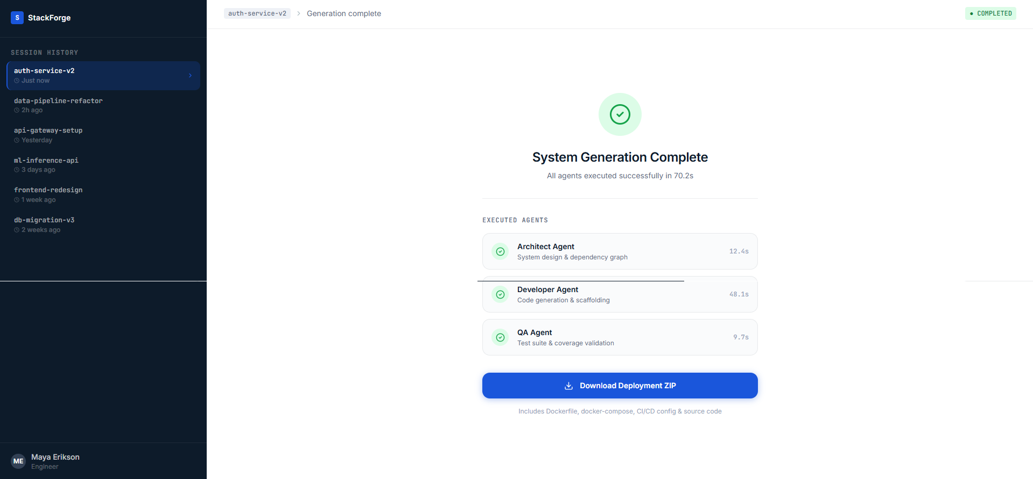 When generation finishes, the user gets one button to download a ZIP with the code, Dockerfiles, and SRS (FR-8).

6. Diagrams

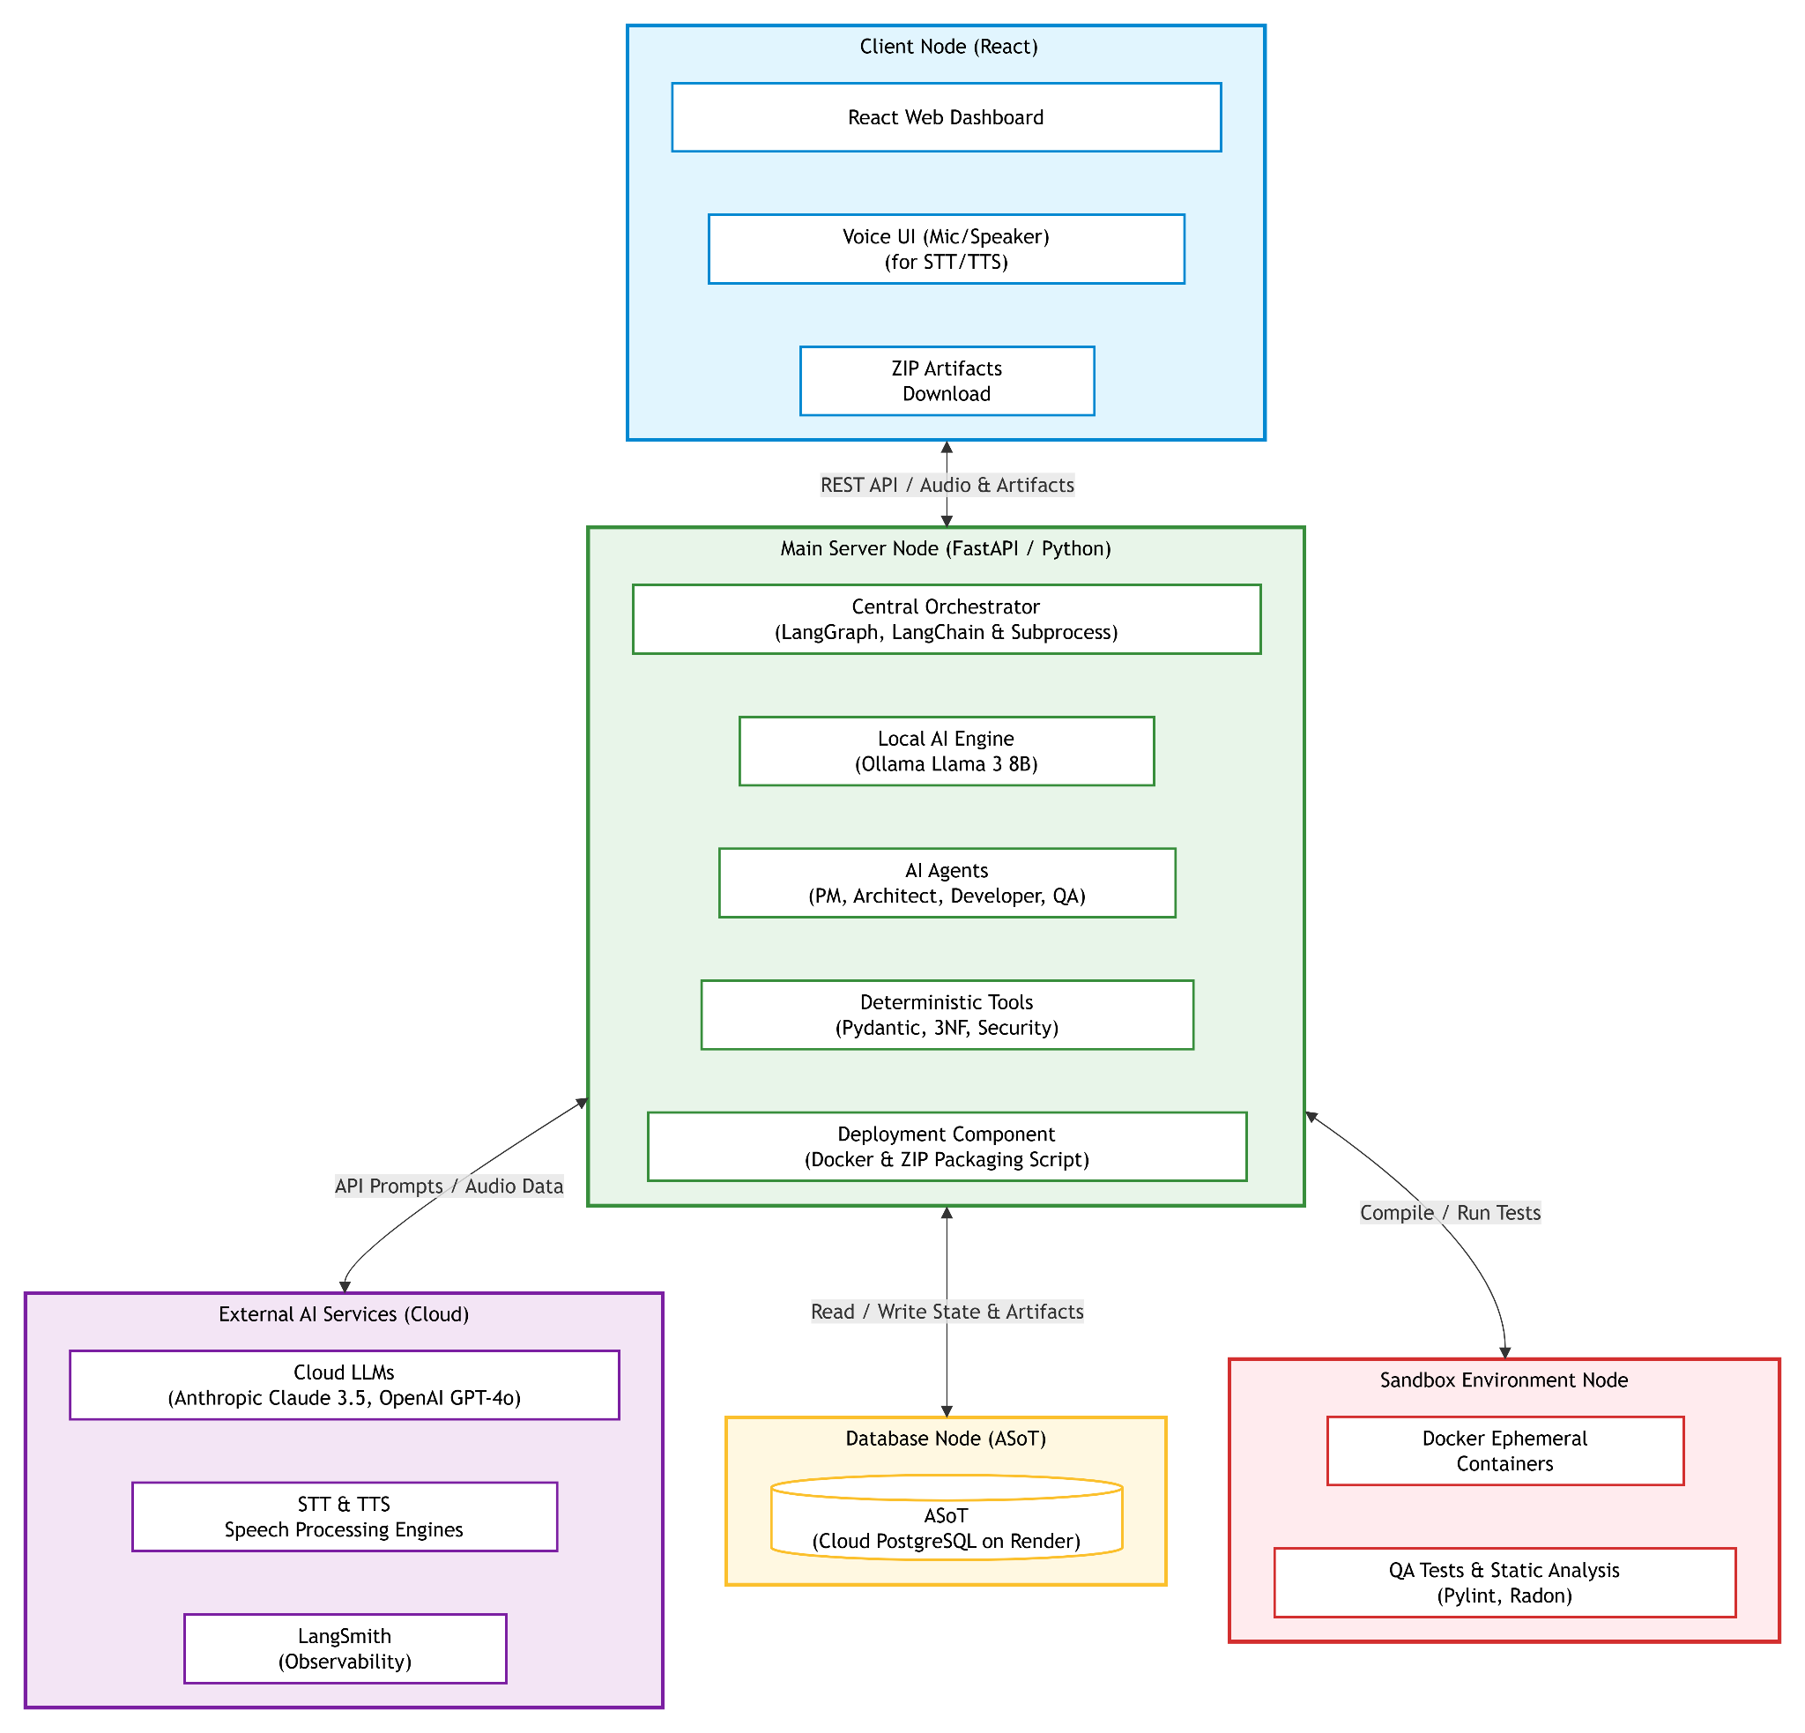
6.1 Package and Deployment

6.2 Use case
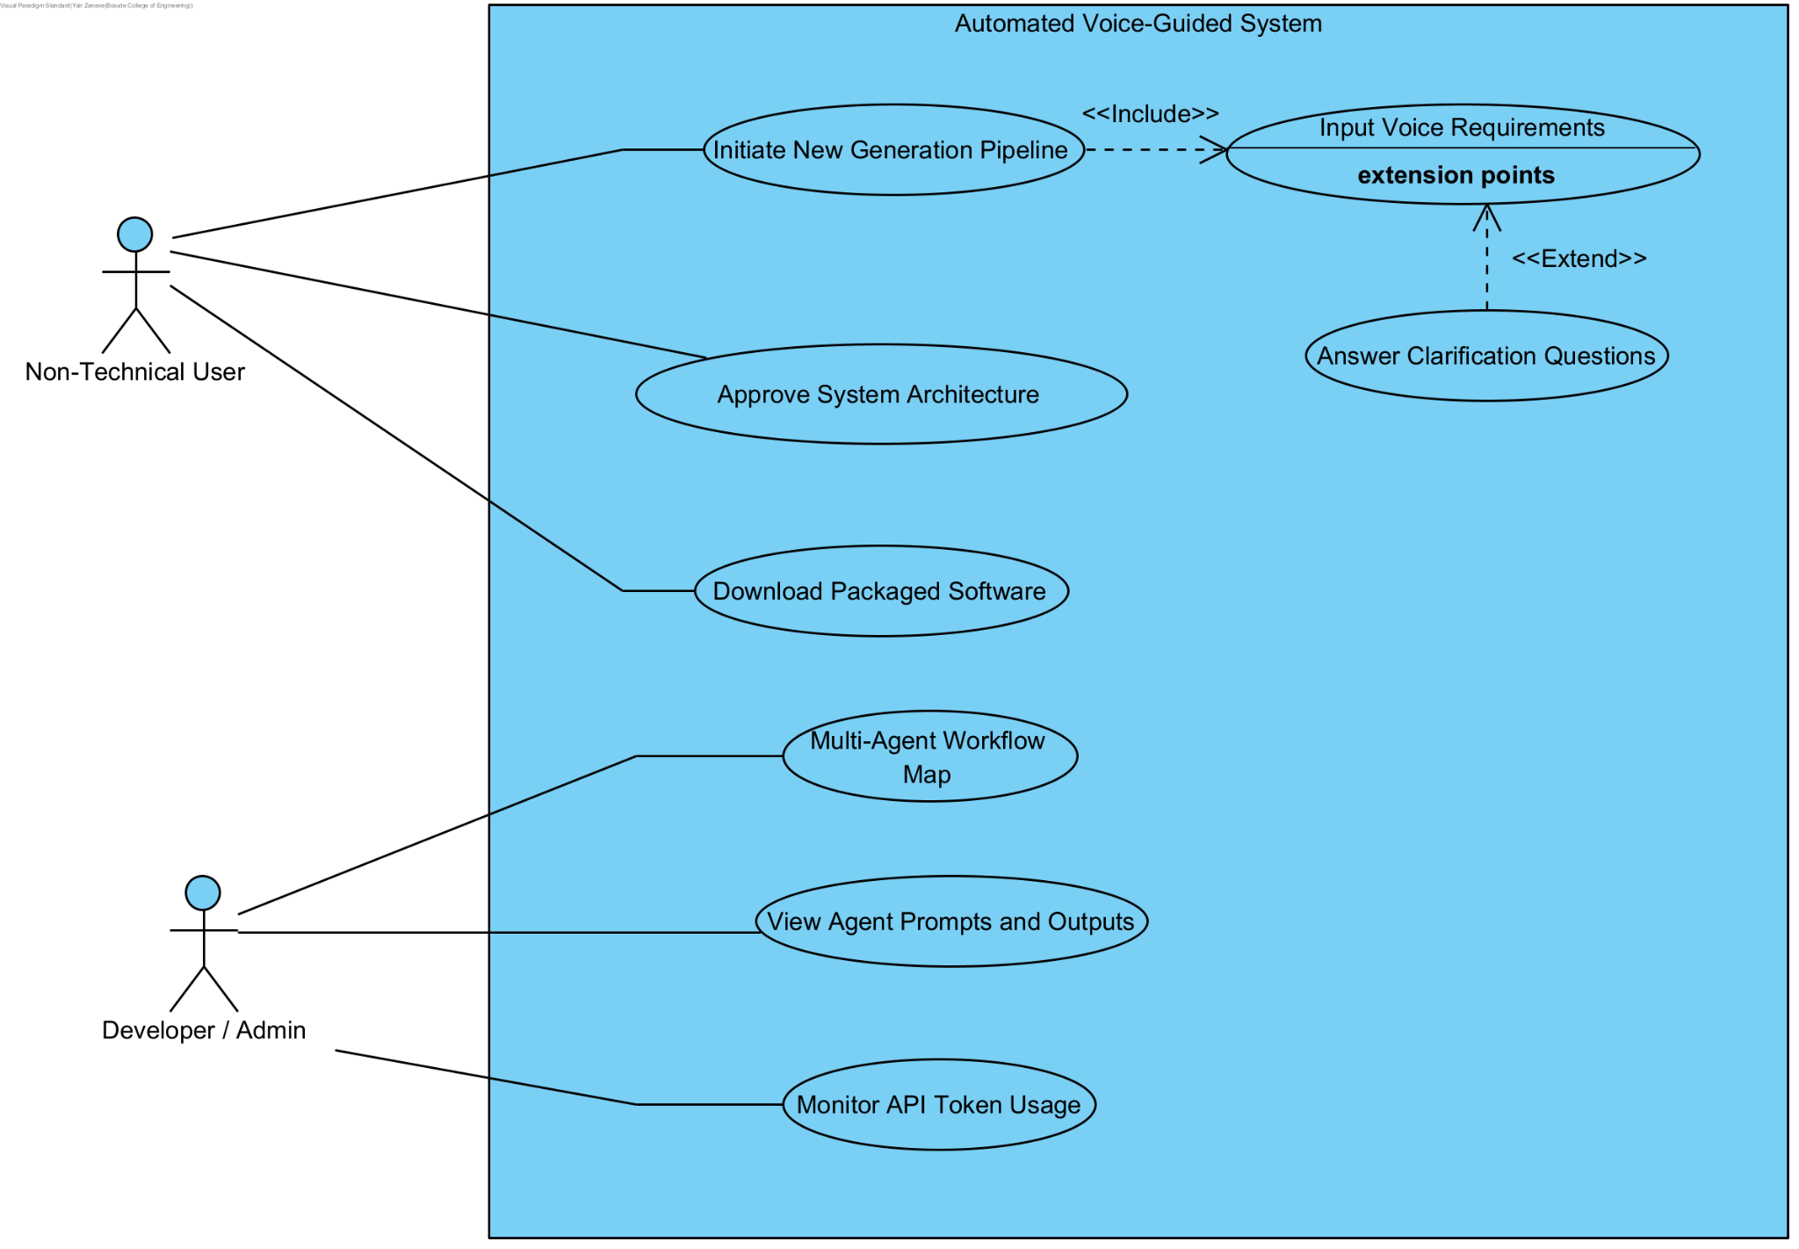

6.3: Activity
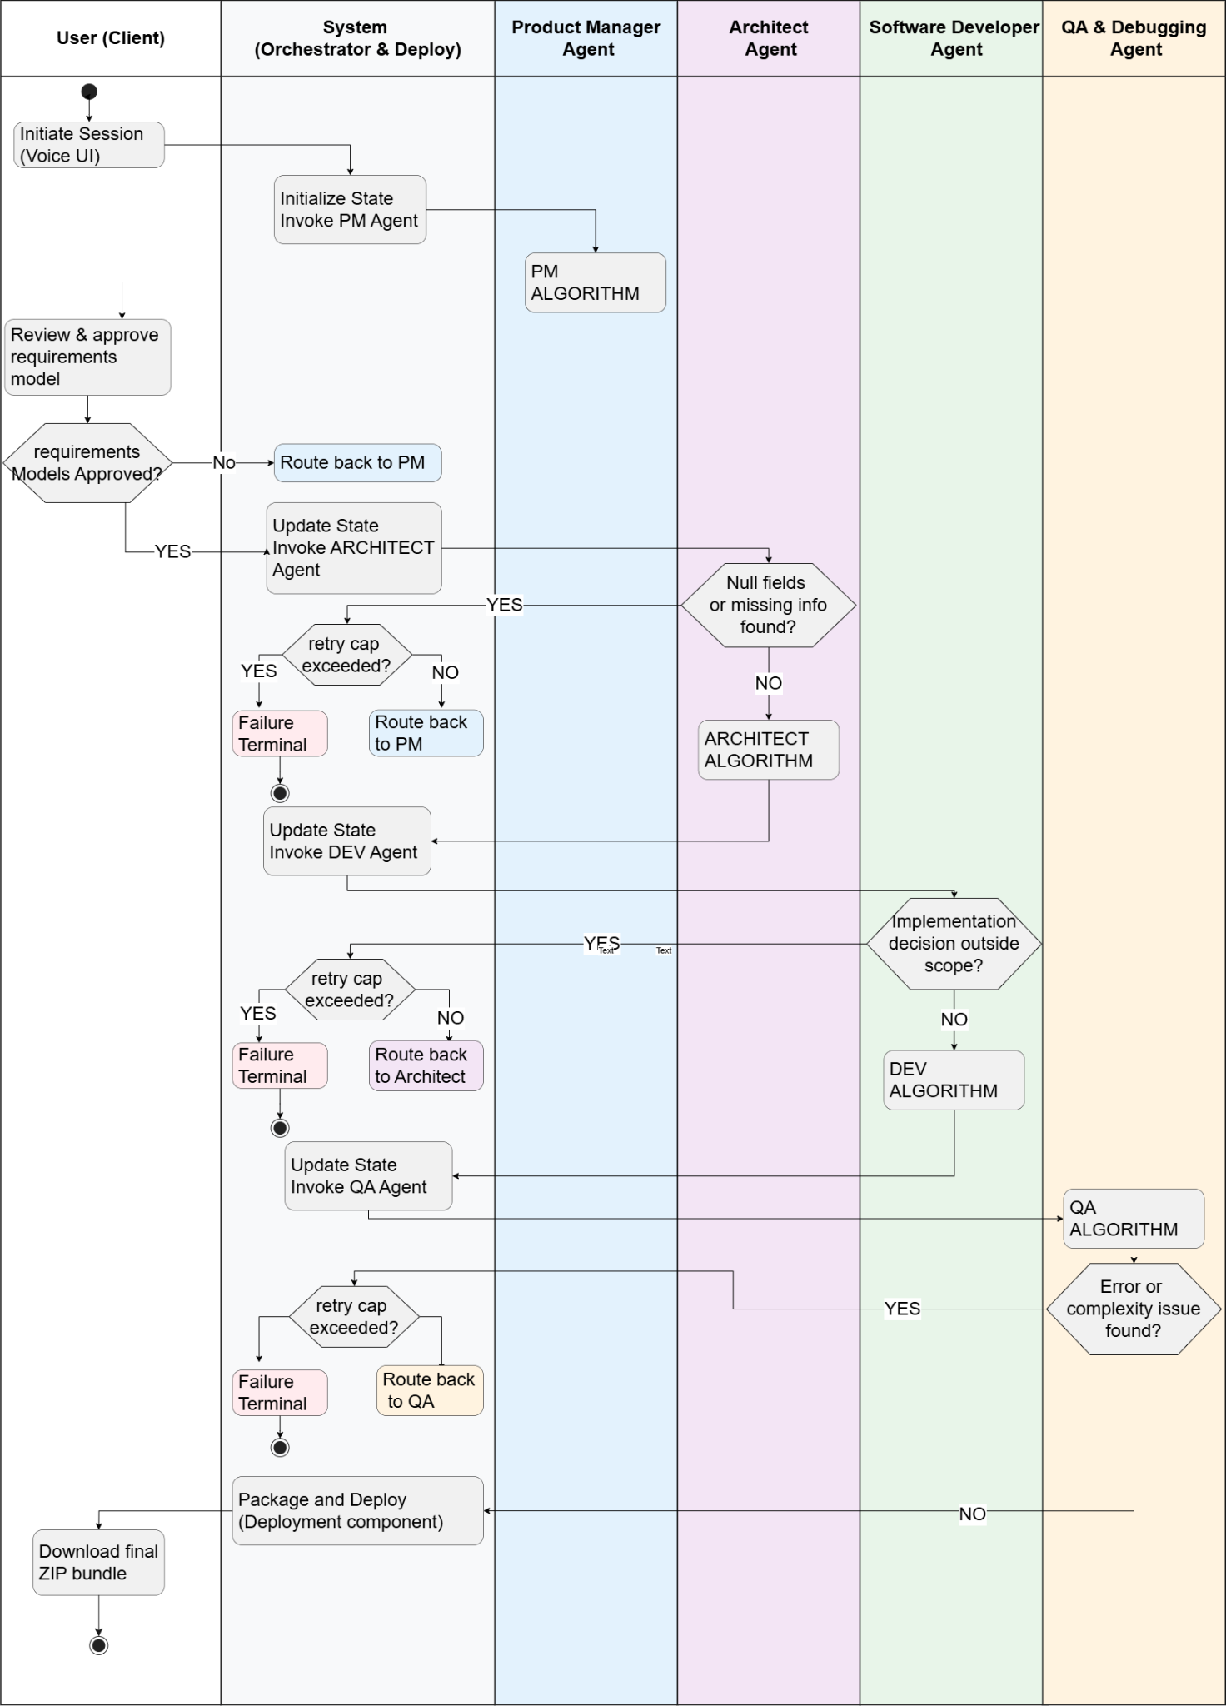

7. Project KPIs & Success Metrics
The metrics in this section are designed to prove that the system generates stable, working software rather than just conversational text. For this reason, the KPIs focus on strict engineering standards, such as IEEE guidelines for requirements, 3NF for database schemas, and standard complexity limits for code. All technical targets are measured automatically using deterministic tools (like Pylint, Radon, and openapi-spec-validator) and isolated Docker execution, strictly avoiding "LLM as a judge" methods. The system's overall success is then measured by real users through User Acceptance Testing (UAT).

7.1 Requirements Elicitation (PM Agent)
KPI | Target | Measurement
SRS IEEE 29148 field completeness | 100% of mandatory requirement fields populated before phase transition | Automated checklist scan against IEEE 29148 section requirements
Dialogue efficiency | Requirements model completed in ≤ N turns on average | Turn count logged per session
STT Word Error Rate (WER) | ≤ 10% under standard acoustic conditions | WER evaluation against a defined test phrase set

7.2 Architectural Design (Architect Agent)
KPI | Target | Measurement
FR coverage in API contract | 100% of functional requirements map to at least one API endpoint | Automated set-difference check between ASoT requirement IDs and generated contract
Schema normalization | 100% of generated schemas pass Third Normal Form verification | Deterministic 3NF checker output
API contract OpenAPI 3.x conformance | Zero schema violations | openapi-spec-validator run against generated contract

7.3 Code Quality & Correctness (Developer + QA Agents)
KPI | Target | Measurement
Test suite pass rate | 100% of generated tests pass before advancing to deployment | QA sandbox execution report
API endpoint test coverage | 100% of REST endpoints covered by at least one integration test | Coverage report
Cyclomatic complexity | ≥ 95% of functions score ≤ 10, hard ceiling of 15 | Radon static analysis
Cognitive complexity | ≥ 95% of methods score ≤ 15, hard ceiling of 20 | Radon static analysis
Requirement traceability | 100% of approved requirement IDs appear as metadata tags in the generated source code | Automated cross-reference scan of ASoT IDs vs. code annotations
Self-correction convergence rate | Reported as empirical result across all test runs: ratio of projects reaching a passing build before the retry cap | QA agent exit-state logs

7.4 End-to-End System
KPI | Target | Measurement
Pipeline success rate | 100% of test projects produce a deployable Docker build without human intervention | Automated runs across N pre-defined scenarios of varying complexity
Docker deployment success | 100% of QA-passed builds deploy successfully in a Docker environment | Automated deployment test
First response latency | ≤ 3 seconds from user input to first text token | System logs
TTS playback latency | ≤ 7 seconds from user speech input to audible playback | System logs
UAT success rate | ≥ 80% of non-technical participants complete the full pipeline and produce a deployable build without guidance from the development team | Structured UAT sessions (see Section 6.5)

8. Testing Plan
The testing matrix evaluates the operational stability, deterministic logic gates, and inter-agent coordination of the multi-agent development framework.

8.1 Unit Testing - Deterministic Modules
These tests isolate and evaluate the individual, code-level validation scripts and rule-based modules developed for the platform, utilizing zero LLM logic.
What is being tested | Expected Result
IEEE 29148 Completeness Checker Module: Inputting an incomplete requirement data structure missing mandatory structural fields. | The checker flags the missing fields, blocks phase transition, and prevents the framework from saving an invalid state.
Interviewer Contradiction Gate: Inputting a user requirement string that logically conflicts with a previously saved database record. | The module catches the conflict, flags the specific database fields, and generates a targeted resolution prompt.
STT Post-Processing Validator: Inputting a corrupted, silent, or completely empty audio transcription string. | The platform isolates the processing failure and programmatically triggers a verbal request for user re-entry.
Pydantic Structure Validator: Feeding a structurally broken or malformed JSON payload from an agent into a data boundary. | The validator immediately throws an exception, halts downstream orchestration, and prevents database memory corruption.
3NF Normalization Checker: Passing a relational database entity model containing partial or transitive functional dependencies. | The module identifies the normalization failures and triggers a targeted re-invocation loop for that specific table sub-block.
API Coverage Checker: Inputting a backend contract that lacks an endpoint definition for an approved functional requirement ID. | The checker runs a set difference, isolates the unmapped requirement ID, and flags the precise functional gap for generation.
Constraint Satisfaction Filter: Inputting an architectural framework candidate that violates the user's hard non-functional parameters. | The filter catches the violation, purges the non-compliant framework from the options array, and returns only fully valid stacks.

8.2 Integration Testing - Inter-Agent Data Contracts
Integration testing verifies data handoffs, rule enforcement, and state transitions over the Authoritative Source of Truth (ASoT) boundaries between adjacent agent nodes.
What is being tested | Expected Result
PM Agent to ASoT Integration: Saving a newly compiled requirement model payload into the central PostgreSQL database. | The backend commits the dataset matching the exact RequirementsModel typed schema layout without dropping data fields.
ASoT to Architect Agent Handoff: The central Orchestrator extracts a requirement dataset from the database and passes it to the Architect node. | The system successfully parses the incoming model against the Architect’s boundary schema with zero data-type mismatches.
Architect to Developer Handoff: Transferring the generated system design and API contracts down into the source code generation engine. | The DesignDocument payload validates against the Developer agent's input structures without triggering data parsing exceptions.
Developer Code Halt & Clarification Trigger: The Developer agent hitting an unmapped code block or structural gap mid-generation. | The agent halts compilation, writes a clear clarification request to the ASoT, and the Orchestrator safely routes control back to the Architect.
Security-Enforcement Integration: Passing raw generated full-stack code strings through the platform’s security injection script. | The tool parses the file, embeds parameterized query layouts, wraps inputs in validation functions, and outputs a secure script block.
MyPy Code Verification Filter: Running the internal type checking gate on a newly synthesized Python code file. | The platform catches any internal script syntax breaks or type errors and feeds line-by-line feedback back to the development agent.

8.3 Sandbox QA Testing - Platform Verification Loop
These tests evaluate our platform’s autonomous sandbox infrastructure, log capture mechanics, and self-correction routing capabilities.
What is being tested | Expected Result
Docker Sandbox Provisioning Subsystem: The Orchestrator initializing a testing block sequence for unverified generated code repositories. | The platform spins up a lightweight, containerized Docker sandbox environment and safely mounts the script files in isolation.
Error Stream & Stack Trace Extraction: An unverified application script hitting a compilation crash or test failure inside the running container. | The sandbox capture mechanism extracts the raw standard error stream (stderr), builds a diagnostic packet, and routes it to the QA agent.
Orchestrator Retry Cap Enforcement: The platform's automated code repair loop failing to resolve a runtime script bug after multiple attempts. | The Orchestrator halts code repair precisely at execution iteration $N$, logs a diagnostic failure report, and transfers to the terminal node.
Static Code Metric Analytics Integration: Invoking the platform's internal Pylint and Radon validation tools against a generated repository. | The tools parse the files, calculate complexity scores, and return structured metric evaluations to the platform state database.

8.4 End-to-End Pipeline Testing
End-to-End testing verifies the platform's multi-agent workflow, graph routing accuracy, and structural crash resilience across controlled test cases.
What is being tested | Expected Result
LangGraph Rule-Based Routing Flow: Driving a pre-defined test scenario sequentially through the complete multi-agent engineering network. | The rule-based Orchestrator sequences nodes without getting stuck or dropping session state.
Orchestrator State Recovery Check: Inducing a hard runtime exception or system crash inside an active agent mid-pipeline. | LangGraph automatically persists the active session state to the database, ensuring all prior confirmed ASoT data remains fully intact upon restart.

8.5 User Acceptance Testing (UAT)
UAT confirms frontend portal usability, voice dialogue ingestion systems, and manual human-in-the-loop overrides.
What is being tested | Expected Result
Human-in-the-Loop Model Modification: A user manually editing, expanding, or approving a structural requirement via the visual dashboard portal. | The platform backend seamlessly merges user edits into the active ASoT requirement model without corrupting existing historical data.
Unassisted Platform Operation: Non-technical target users executing a full software generation session via the platform interface. | The platform guides users through the voice dialogue, allows 'Express Approve' confirmation, and successfully packages a downloadable deployment bundle.

8.6 AI Tools & Prompts
Tools: Perplexity + Deep Research, Claude, Gemini, NotebookLM

Prompts:
- “Act as an elite, brutally honest Academic Advisor and Computer Science Thesis Reviewer. We are evaluating and refining the architecture, algorithms, and technical descriptions for my Bachelor's/Master's final degree project. “
- “I'm working on a final project for my Software Engineering degree and the first step is to find proper source material, this means acclaimed books and recognized research papers on certain subjects. “

- “Act as my college thesis reviewer. I'm going to provide you with my final project's thesis and a trimmed version. I want you to analyze both then compare them and critique the trimming if it negatively affected the arguments made “

9. References
[1] IEEE Std 29148-2018, Systems and Software Engineering - Life Cycle Processes - Requirements Engineering, IEEE, 2018.
[2] A. van Lamsweerde, Requirements Engineering: From System Goals to UML Models to Software Specifications, Chichester, UK: John Wiley & Sons, 2009.
[3] D. Jin, W. Sun, J. Huang, P. Liang, J. Xuan, Y. Liu, and Z. Jin, "iReDev: A Knowledge-Driven Multi-Agent Framework for Intelligent Requirements Development," ACM Transactions on Software Engineering and Methodology (TOSEM), vol. 35, no. 4, art. no. 112, July 2025.
[4] H. Cheng, J. H. Husen, Y. Lu, T. Racharak, N. Yoshioka, N. Ubayashi, and H. Washizaki, "Generative AI for Requirements Engineering: A Systematic Literature Review," Software: Practice and Experience, vol. 56, no. 1, pp. 45–74, Jan. 2025.
[5] Z. Ke, Y. Ming, A. Xu, R. Chin, X.-P. Nguyen, P. Jwalapuram, J. Wang, S. Yavuz, C. Xiong, and S. Joty, "MAS-Orchestra: Understanding and Improving Multi-Agent Reasoning Through Holistic Orchestration and Controlled Benchmarks," arXiv preprint arXiv:2601.14652, Jan. 2026.
[6] S. Chen et al., "Self-Debugging: Teaching Large Language Models to Self-Debug," in Proceedings of the International Conference on Learning Representations (ICLR), 2024.
[7] C. Qian et al., "ChatDev: Communicative Agents for Software Development," arXiv preprint arXiv:2308.08155, 2023.
[8] S. Hong et al., "MetaGPT: Meta Programming for a Multi-Agent Collaborative Framework," arXiv preprint arXiv:2308.00352, 2024.
[9] J. Gou et al., "CRITIC: Large Language Models Can Self-Correct with Tool-Use," in Proceedings of the International Conference on Learning Representations (ICLR), 2024.
[10] D. Tran and D. Kiela, "Single-Agent LLMs Outperform Multi-Agent Systems on Multi-Hop Reasoning Under Equal Thinking Token Budgets," arXiv preprint arXiv:2604.02460, Apr. 2026. [11] D. Hansen, Model-Based Systems Engineering in the Era of Generative AI: Transitioning from Document-Centric to Model-Centric Truth, Boston, MA: Academic Press, 2026.
[12] H. Cheng, M. Kim, F. Khomh, T. Racharak, N. Yoshioka, N. Ubayashi, and H. Washizaki, "QUARE: Multi-Agent Negotiation for Balancing Quality Attributes in Requirements Engineering," arXiv preprint arXiv:2603.11890, Mar. 2026.

Appendices

3.1 Functional Requirements (FR)
ID | Category | Streamlined Engineering Description
FR-1.1 | Voice Input | The system shall detect invalid or inaudible voice inputs and programmatically prompt the user to repeat the statement.
FR-1.2 | Voice Input | The Interviewer sub-agent shall parse the transcribed text, identify missing functional information, and dynamically generate targeted clarification queries.
FR-1.3 | Voice Output | The system shall convert all text responses into audible speech using a Text-to-Speech (TTS) engine.
FR-2.1 | Clarification Dialogue | The Interviewer sub-agent shall flag and resolve logical contradictions and ambiguities in user statements before advancing the dialogue.
FR-2.2 | Clarification Dialogue | The Interviewer sub-agent shall systematically elicit functional goals and non-functional constraints before concluding the session.
FR-3.1 | Human-in-the-Loop | The system shall accept manual corrections or extensions to the requirements model during the HITL review stage without resetting the active session.
FR-3.2 | Context Preservation | The system shall incrementally merge user corrections into the ASoT, maintaining all previously approved and unmodified data structures.
FR-4.1 | Documentation | The system shall auto-generate structured user stories directly from the validated requirements model.
FR-4.2 | Documentation | The system shall auto-generate a normalized, fully mapped relational database schema matching the approved model.
FR-4.3 | Documentation | The system shall auto-generate an OpenAPI/REST-compliant API specification derived from the approved model.
FR-4.4 | Documentation | The system shall auto-generate an Architecture Decision Record (ADR) for each major structural decision made by the Architect agent, documenting the decision taken, its rationale, the alternatives considered, and the functional or non-functional requirement it satisfies.
FR-5.1 | Code Traceability | All generated documentation and source code files shall include metadata mapping them explicitly back to their corresponding nodes in the requirements model.
FR-5.2 | Generation Security | The system shall programmatically embed input validation, parameterized database queries, and access-control checks into the generated code to prevent data injection and unauthorized API access
FR-6.1 | Test Generation | The system shall automatically generate a comprehensive suite of unit and integration tests based on the ASoT rules and API contracts
FR-6.2 | Test Execution | The sandbox pipeline shall execute the test suite and log structural pass/fail reports for downstream evaluation.
FR-6.3 | Automated V&V | The system shall run static analysis tools to capture cyclomatic complexity, cognitive complexity, code maintainability metrics, and compiler logs.
FR-6.4 | Self-Correction | The Debugging sub-agent shall analyze the compiled diagnostic packets and execute iterative self-correction cycles until all metrics pass or the retry cap is met.
FR-7.1 | Orchestration | Sub-agents shall remain completely stateless, wiping all temporary data from memory as soon as their assigned task finishes.
FR-8 | Output Delivery | The platform shall package the final SRS, user stories, database schema, API specifications, and full-stack codebase into a single downloadable ZIP bundle.

3.2 Non-Functional Requirements (NFR)
ID | Category | Streamlined Engineering Description
NFR-2 | Other – STT Accuracy | The STT engine shall maintain a Word Error Rate <= 10% when processing a native speaker under standard acoustic conditions.
NFR-3.1 | Usability – Text Response Time | The system shall generate the first token of text clarification within 3 seconds of user input submission.
NFR-3.2 | Usability – Speech Response Time | The system shall initiate audible playback of synthesized speech within 7 seconds of receiving a user speech block.
NFR-6.1 | Maintainability – Cyclomatic limit | At least 95% of generated functions must have a cyclomatic complexity score of 10 or less, and no function shall exceed a score of 15. Measured via static control-flow graph analysis, counting the number of linearly independent paths ($M=E-V+2P$) through the source code.
NFR-6.2 | Maintainability – Cognitive limit | At least 95% of generated methods shall yield a cognitive complexity score <= 15, with a strict ceiling constraint of 20 across all methods. Measured via static analysis tools by applying structural weighting that increments linearly based on nesting depth levels (e.g. if & do) and control flow breaks.
NFR-8 | Security – Data Handling & Privacy | No raw audio recordings shall be stored permanently; text transcriptions shall be deleted at session termination unless a project is explicitly saved.
NFR-11 | Usability – End-User Success | User Acceptance Testing (UAT) must verify that at least 80% of non-technical test subjects produce a deployable build without guidance from the development team

4. Research and Development Methodology

4.1.1 Central Orchestrator
Algorithmic Flow:
Session starts → state initialized (phase = PM, all retry counters = 0)
→ Invoke PM → completes → advance to Architect
→ Invoke Architect → completes → advance to Developer
→ Architect writes clarification request to ASoT → route back to PM → resume Architect on resolution
→ Architect retry counter exceeds cap → route to failure terminal
→ Invoke Developer → completes → advance to QA
→ Developer encounters an implementation decision outside the design document's scope → writes clarification request to ASoT → Orchestrator routes to Architect → Architect updates the relevant section, writes resolution to ASoT → routes back to Developer, resume
→ Developer's architectural-clarification retry counter exceeds cap → route to failure terminal
→ Invoke QA → all tests pass → advance to Deployment
→ QA test failure → QA analyzes root cause and applies a targeted code fix to ASoT → Orchestrator increments QA repair counter and routes back to QA to re-run test suite → QA repair counter exceeds cap → route to failure terminal
→ Invoke Deployment → completes → package artifacts → END
→ Any agent raises a runtime exception at any phase → log to ASoT, route to failure terminal, prior state preserved

4.1.2 Product Manager (PM) Agent
Algorithmic Flow (Reason + Act Loop):
Read current confirmed requirements from ASoT + latest user transcript
→ Reason: LLM evaluates the new input, identifying what requirements were just confirmed, what is still missing to satisfy IEEE 29148, and whether anything the user just said contradicts something previously confirmed
→ Contradiction found? Generate a targeted resolution question → re-enter loop
→ Missing requirements remain? Generate a single focused clarification question →
re-enter loop
→ Everything confirmed and consistent: write validated requirements to ASoT
→ Deterministic completeness check passes → advance to Architect Agent
The termination condition is a code-level check against the requirements model, not an LLM judgment.

4.1.3 Architect Agent
Algorithmic Flow (Constrained Design Loop):
Fetch validated requirements + extract hard constraints from ASoT → Deterministic scan of requirements model for null fields, undefined references → gap found? → Write clarification request to ASoT → Orchestrator routes to PM → resume on resolution → LLM generates component breakdown, technology candidates, entity-relationship draft → Constraint filter eliminates invalid candidates → none remain? → write conflict to ASoT → Orchestrator routes to PM → LLM generates ADRs → completeness checker flags missing fields → regenerate → re-check → LLM outputs entity model → Pydantic validates → 3NF checker runs → violations found? → LLM resolves flagged dependencies → re-run → clean → LLM generates API contract → coverage checker runs → gaps found? → LLM generates missing endpoints → re-run → full coverage confirmed → Any retry cap exceeded? → write failure diagnostic to ASoT →
Orchestrator routes to failure terminal → All checks pass → commit design document to ASoT → advance to Developer Agent

4.1.4 Software Developer Agent
Algorithmic Flow (Pause and Wake + Tool Validation):
Fetch relational database schemas, API contracts, and finalized user stories from ASoT → Gap found in architectural scope? → Agent halts, writes clarification request to ASoT → Orchestrator routes back to Architect → continue execution
→ Generate code: LLM generates database scripts, REST API endpoints, and UI components → Execute Security-Enforcement, Traceability-Mapper & MyPy Tools → Tools report injection, mapping, or syntax failure (e.g., unmappable code structure, vulnerable raw SQL query, or MyPy type errors)?→ Agent analyzes tool feedback, modifies ONLY the specific block, and re-runs tools
→ Tools execution successful? → Commit complete source code repository to ASoT → Advance to QA & Debugging Agent

4.1.5 QA & Debugging Agent
Algorithmic Flow (Self-Correction Loop):
Fetch raw source code, API definitions, and formal requirements from ASoT → Generate tests: drafts unit and integration test suite → Sandbox execution: deterministic code runs compiler, tests, and static analysis tools inside an isolated Docker container
→ Error or complexity issue found? → Extract stack traces → analyzes root cause and writes a targeted code fix → deterministic code applies the fix to the codebase → increment repair counter → re-enter loop
→ Retry limit reached? → Write failure diagnostic to ASoT → Orchestrator routes to failure terminal
→ All tests and metrics pass? → Commit verified source code and quality reports to ASoT → Advance to Deployment

4.1.6 Deployment Component
Algorithmic Flow (Packaging Pipeline):
verified code and SRS document from ASoT → Write standard Dockerfiles and Docker Compose scripts → Package the code, Docker files, and SRS into a single ZIP archive → Save ZIP file to ASoT → END

